|  |  |  |  |
| --- | --- | --- | --- |
| Nama Fitur | | Halaman Login |  |
| Diterima | | ✓ |
| Direvisi | |  |
| Catatan | | |
|  | | |
| Ttd |  | |

|  |  |  |  |
| --- | --- | --- | --- |
| Nama Fitur | | Halaman Dashboard |  |
| Diterima | | ✓ |
| Direvisi | |  |
| Catatan | | |
|  | | |
| Ttd |  | |

|  |  |  |  |
| --- | --- | --- | --- |
| Nama Fitur | | Halaman Kasir |  |
| Diterima | | ✓ |
| Direvisi | |  |
| Catatan | | |
|  | | |
| Ttd |  | |

|  |  |  |  |
| --- | --- | --- | --- |
| Nama Fitur | | Halaman Produk |  |
| Diterima | | ✓ |
| Direvisi | |  |
| Catatan | | |
|  | | |
| Ttd |  | |

|  |  |  |  |
| --- | --- | --- | --- |
| Nama Fitur | | Halaman Tambah Produk |  |
| Diterima | | ✓ |
| Direvisi | |  |
| Catatan | | |
|  | | |
| Ttd |  | |

|  |  |  |  |
| --- | --- | --- | --- |
| Nama Fitur | | Halaman Edit Produk |  |
| Diterima | | ✓ |
| Direvisi | |  |
| Catatan | | |
|  | | |
| Ttd |  | |

|  |  |  |  |
| --- | --- | --- | --- |
| Nama Fitur | | Halaman Stok |  |
| Diterima | | ✓ |
| Direvisi | |  |
| Catatan | | |
|  | | |
| Ttd |  | |

|  |  |  |  |
| --- | --- | --- | --- |
| Nama Fitur | | Halaman Tambah Stok |  |
| Diterima | | ✓ |
| Direvisi | |  |
| Catatan | | |
|  | | |
| Ttd |  | |

|  |  |  |  |
| --- | --- | --- | --- |
| Nama Fitur | | Halaman Edit Stok |  |
| Diterima | | ✓ |
| Direvisi | |  |
| Catatan | | |
|  | | |
| Ttd |  | |

|  |  |  |  |
| --- | --- | --- | --- |
| Nama Fitur | | Halaman Satuan |  |
| Diterima | | ✓ |
| Direvisi | |  |
| Catatan | | |
|  | | |
| Ttd |  | |

|  |  |  |  |
| --- | --- | --- | --- |
| Nama Fitur | | Halaman Tambah Satuan |  |
| Diterima | | ✓ |
| Direvisi | |  |
| Catatan | | |
|  | | |
| Ttd |  | |

|  |  |  |  |
| --- | --- | --- | --- |
| Nama Fitur | | Halaman Edit Satuan |  |
| Diterima | | ✓ |
| Direvisi | |  |
| Catatan | | |
|  | | |
| Ttd |  | |

|  |  |  |  |
| --- | --- | --- | --- |
| Nama Fitur | | Halaman Harga Produk |  |
| Diterima | | ✓ |
| Direvisi | |  |
| Catatan | | |
|  | | |
| Ttd |  | |

|  |  |  |  |
| --- | --- | --- | --- |
| Nama Fitur | | Halaman Tambah Harga Produk |  |
| Diterima | | ✓ |
| Direvisi | |  |
| Catatan | | |
|  | | |
| Ttd |  | |

|  |  |  |  |
| --- | --- | --- | --- |
| Nama Fitur | | Halaman Edit Harga Produk |  |
| Diterima | | ✓ |
| Direvisi | |  |
| Catatan | | |
|  | | |
| Ttd |  | |

|  |  |  |  |
| --- | --- | --- | --- |
| Nama Fitur | | Halaman Transaksi |  |
| Diterima | | ✓ |
| Direvisi | |  |
| Catatan | | |
|  | | |
| Ttd |  | |

|  |  |  |  |
| --- | --- | --- | --- |
| Nama Fitur | | Halaman Tambah Transaksi |  |
| Diterima | | ✓ |
| Direvisi | |  |
| Catatan | | |
|  | | |
| Ttd |  | |

|  |  |  |  |
| --- | --- | --- | --- |
| Nama Fitur | | Halaman Edit Transaksi |  |
| Diterima | | ✓ |
| Direvisi | |  |
| Catatan | | |
|  | | |
| Ttd |  | |

|  |  |  |  |
| --- | --- | --- | --- |
| Nama Fitur | | Halaan Detail Transaksi |  |
| Diterima | | ✓ |
| Direvisi | |  |
| Catatan | | |
|  | | |
| Ttd |  | |

|  |  |  |  |
| --- | --- | --- | --- |
| Nama Fitur | | Halaman Transaksi Online |  |
| Diterima | | ✓ |
| Direvisi | |  |
| Catatan | | |
|  | | |
| Ttd |  | |

|  |  |  |  |
| --- | --- | --- | --- |
| Nama Fitur | | Halaman Edit Transaksi Online |  |
| Diterima | | ✓ |
| Direvisi | |  |
| Catatan | | |
|  | | |
| Ttd |  | |

|  |  |  |  |
| --- | --- | --- | --- |
| Nama Fitur | | Halaan Detail Transaksi Online |  |
| Diterima | | ✓ |
| Direvisi | |  |
| Catatan | | |
|  | | |
| Ttd |  | |

|  |  |  |  |
| --- | --- | --- | --- |
| Nama Fitur | | Halaman Pelanggan |  |
| Diterima | | ✓ |
| Direvisi | |  |
| Catatan | | |
|  | | |
| Ttd |  | |

|  |  |  |  |
| --- | --- | --- | --- |
| Nama Fitur | | Halaman Tambah Pelanggan |  |
| Diterima | | ✓ |
| Direvisi | |  |
| Catatan | | |
|  | | |
| Ttd |  | |

|  |  |  |  |
| --- | --- | --- | --- |
| Nama Fitur | | Halaman Edit Pelanggan |  |
| Diterima | | ✓ |
| Direvisi | |  |
| Catatan | | |
|  | | |
| Ttd |  | |

|  |  |  |  |
| --- | --- | --- | --- |
| Nama Fitur | | Halaman Keuangan |  |
| Diterima | | ✓ |
| Direvisi | |  |
| Catatan | | |
|  | | |
| Ttd |  | |

|  |  |  |  |
| --- | --- | --- | --- |
| Nama Fitur | | Halaman Tambah Keuangan |  |
| Diterima | | ✓ |
| Direvisi | |  |
| Catatan | | |
|  | | |
| Ttd |  | |

|  |  |  |  |
| --- | --- | --- | --- |
| Nama Fitur | | Halaman Edit Keuangan |  |
| Diterima | | ✓ |
| Direvisi | |  |
| Catatan | | |
|  | | |
| Ttd |  | |

|  |  |  |  |
| --- | --- | --- | --- |
| Nama Fitur | | Halaman Keranjang Pelanggan |  |
| Diterima | | ✓ |
| Direvisi | |  |
| Catatan | | |
|  | | |
| Ttd |  | |

|  |  |  |
| --- | --- | --- |
| Nama Fitur | Halaman Loading Screen |  |
| Diterima | Trisna, Raflis, Wahyu |
| Direvisi |  |
| Catatan | |
|  | |

|  |  |  |
| --- | --- | --- |
| Nama Fitur | Halaman Login |  |
| Diterima | Trisna, Raflis, Wahyu |
| Direvisi |  |
| Catatan | |
|  | |

|  |  |  |
| --- | --- | --- |
| Nama Fitur | Halaman Home |  |
| Diterima | Trisna, Raflis, |
| Direvisi | Wahyu |
| Catatan | |
| Saya terbiasa dengan keranjang belancara yang berada disudut kanan atas, seperti e-commerce lainnya | |

|  |  |  |
| --- | --- | --- |
| Nama Fitur | Halaman Detail Produk |  |
| Diterima | Trisna, Raflis, Wahyu |
| Direvisi |  |
| Catatan | |
|  | |

|  |  |  |
| --- | --- | --- |
| Nama Fitur | Halaman Keranjang Belanja |  |
| Diterima | Trisna, Raflis, Wahyu |
| Direvisi |  |
| Catatan | |
|  | |

|  |  |  |
| --- | --- | --- |
| Nama Fitur | Halaman Form Belanja Cepat |  |
| Diterima | Trisna, Wahyu |
| Direvisi | Raflis |
| Catatan | |
| Desain dari form belanja cepat dan keranjang sama hampir sama, mohon sedikit ubah konsep mungkin dari warna nantinya dan tambahkan penjelasan detail pada fitur ini. | |

|  |  |  |
| --- | --- | --- |
| Nama Fitur | Halaman Proses Transaksi |  |
| Diterima | ✓ |
| Direvisi |  |
| Catatan | |
|  | |

|  |  |  |
| --- | --- | --- |
| Nama Fitur | Halaman Pembayaran Digital |  |
| Diterima | Trisna, Raflis, Wahyu |
| Direvisi |  |
| Catatan | |
|  | |

|  |  |  |
| --- | --- | --- |
| Nama Fitur | Halaman Pembayaran Digital QRIS |  |
| Diterima | Trisna, ,Wahyu |
| Direvisi | Raflis |
| Catatan | |
| Mohon tambahkan metode pembayaran lainnya. | |

|  |  |  |
| --- | --- | --- |
| Nama Fitur | Halaman Pembayaran Berhasil |  |
| Diterima | Trisna, Raflis, Wahyu |
| Direvisi |  |
| Catatan | |
|  | |

|  |  |  |
| --- | --- | --- |
| Nama Fitur | Halaman Riwayat Belanja |  |
| Diterima | Trisna, Raflis, Wahyu |
| Direvisi |  |
| Catatan | |
|  | |

|  |  |  |
| --- | --- | --- |
| Nama Fitur | Halaman Detail Riwayat Belanja |  |
| Diterima | Trisna, Raflis, Wahyu |
| Direvisi |  |
| Catatan | |
|  | |

|  |  |  |
| --- | --- | --- |
| Nama Fitur | Halaman Profile |  |
| Diterima | Trisna, Raflis, Wahyu |
| Direvisi |  |
| Catatan | |
|  | |

|  |  |  |
| --- | --- | --- |
| Nama Fitur | Halaman Update Profile |  |
| Diterima | Trisna, Raflis, Wahyu |
| Direvisi |  |
| Catatan | |
|  | |

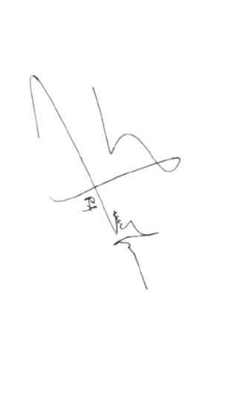Semua form prototipe ini sudah diketahui dan disetujui oleh pihak berikut,

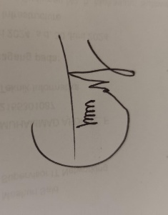

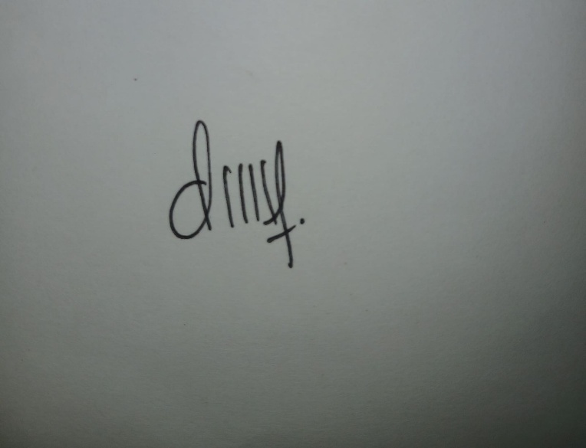 Pelanggan 1 Pelanggan 2 Pelanggan 3

Trisna okta syifa Raflis Harfa, S.T. Wahyudi Nugroho